**BOOTCAMP2**

**Project Overview:**

Developed and deployed an end-to-end retail sales data pipeline using Azure Data Factory (ADF), Azure Data Lake Storage (ADLS), and Azure SQL Database. Integrated data from multiple sources, including REST APIs, CSV files, and an on-prem SQL Server, ensuring efficient ingestion, transformation, and validation.

**Architecture:**

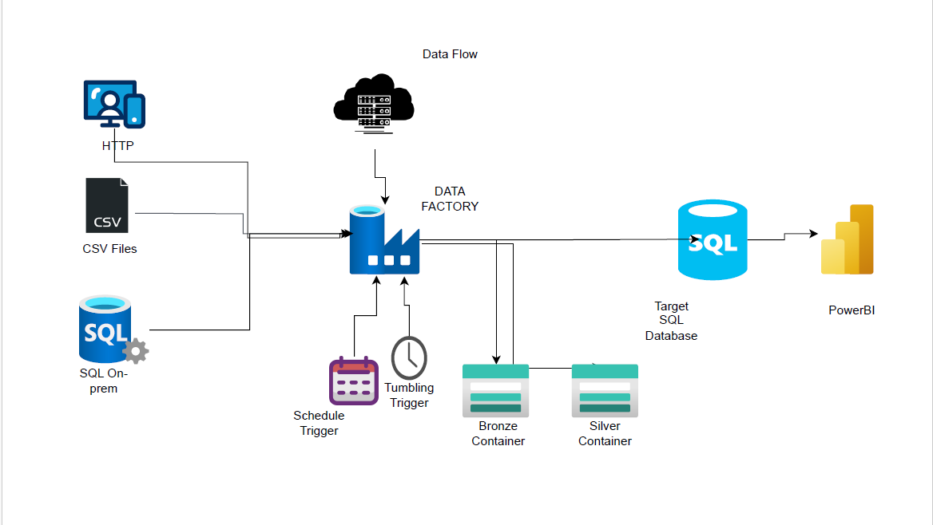

#### Role:

#### ****Key Responsibilities:****

* **Data Ingestion & Integration:**
  + Extracted data from **REST APIs, on-prem SQL Server (via Self-hosted Integration Runtime), and CSV files**.
  + Configured **ADF pipelines** with **Tumbling Window and Scheduled Triggers** for automated ingestion.
* **Data Transformation & Processing:**
  + Implemented **ADF Data Flows** for cleansing, standardization, and aggregation of data.
  + Managed **Bronze (raw), Silver (cleansed), and final Azure SQL layers** for structured storage.
  + Ensured **data validation (row count checks, schema consistency) before loading into Azure SQL Database**.

1. Created All the resources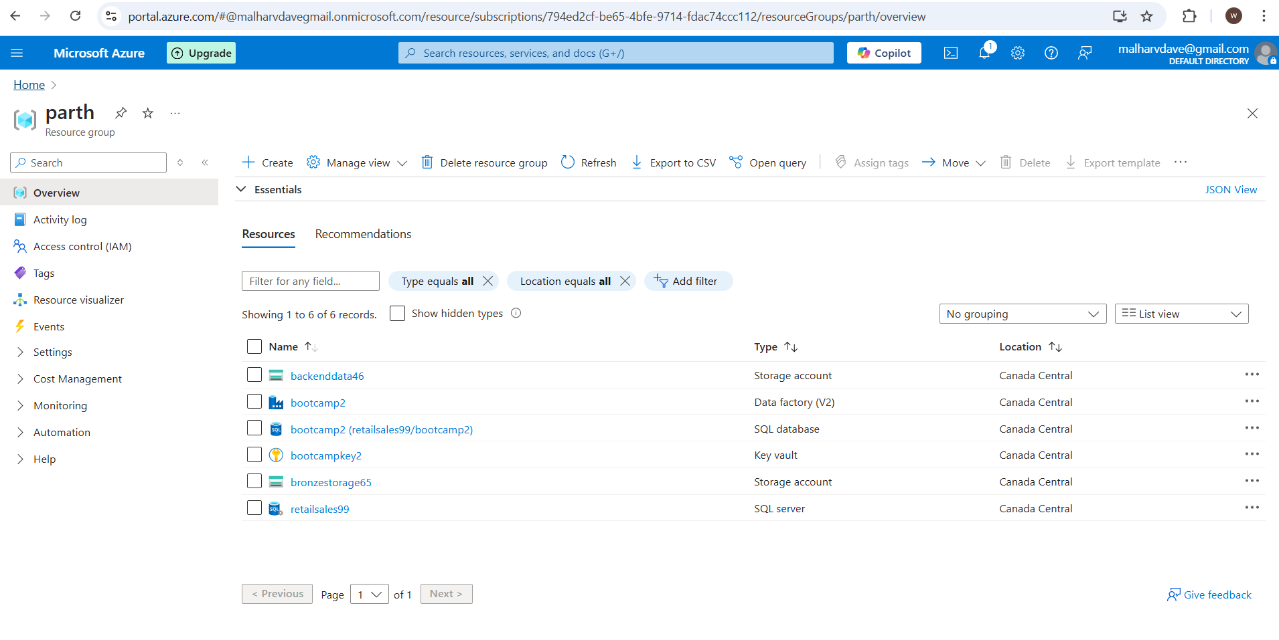

2 . There are three different source 1st one is product present in raw container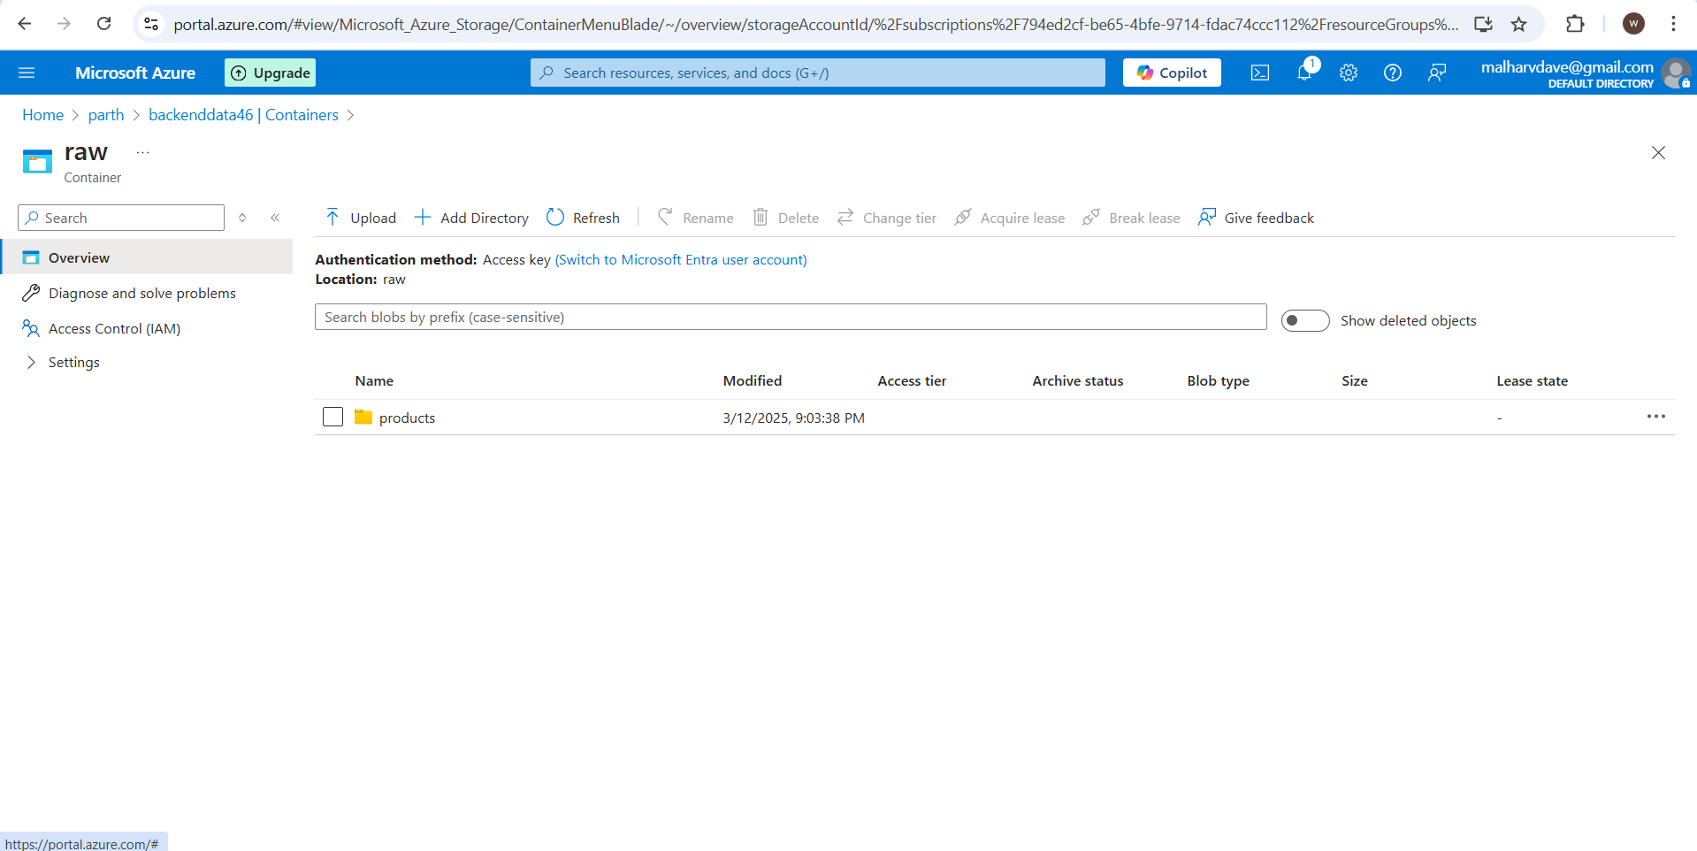

2nd is present in my github as RestApi

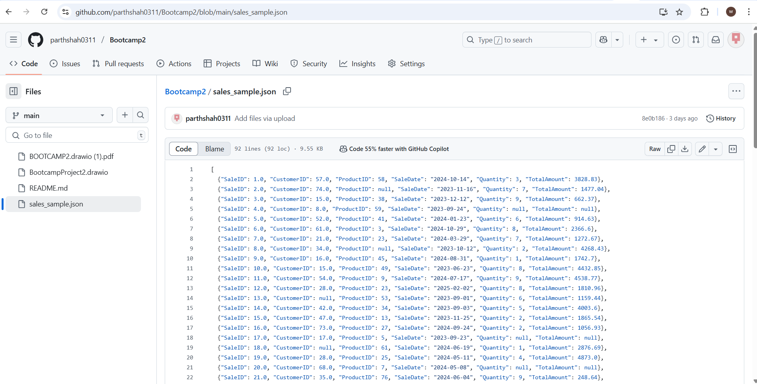

3rd one is present in my onprem sql database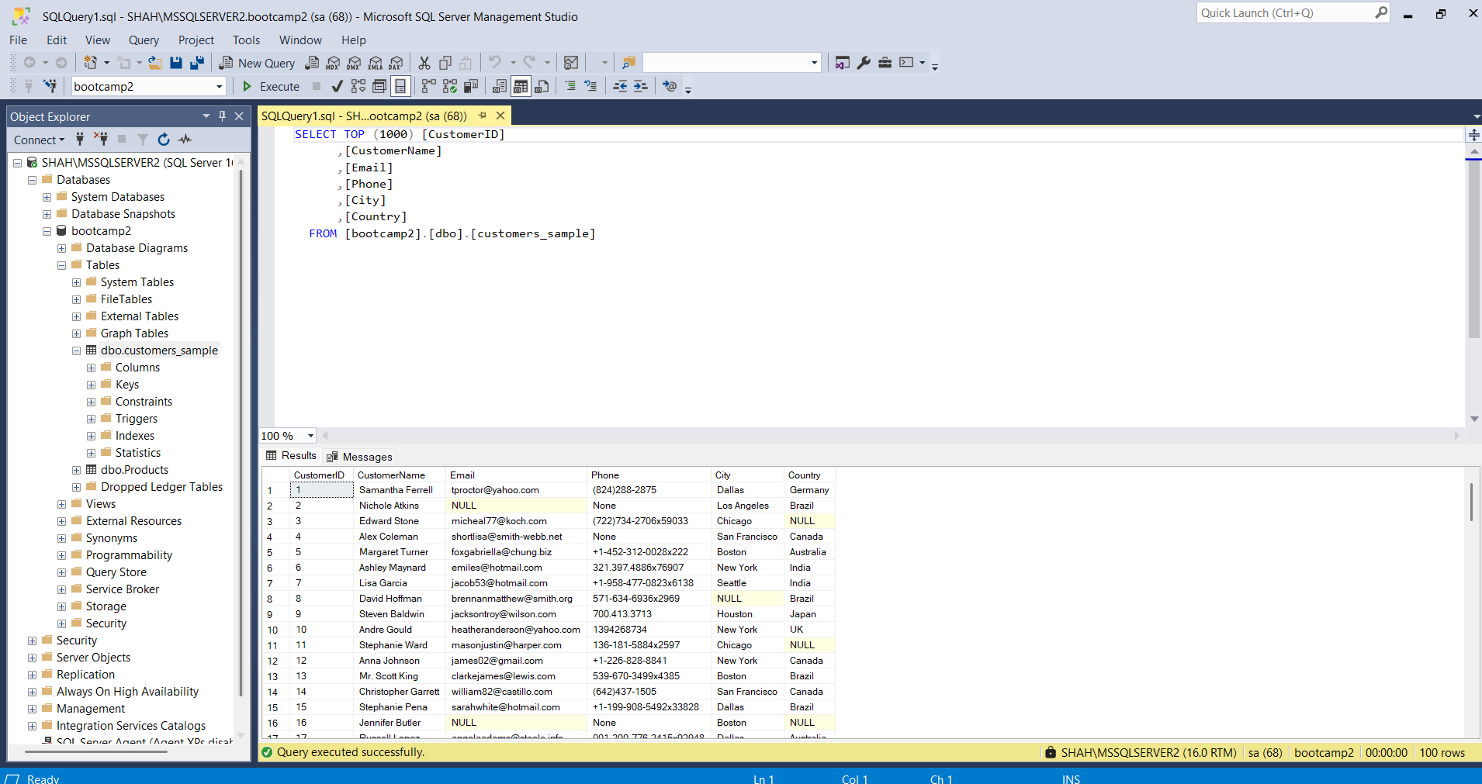

3. Created Pipelines to bring data from raw sources to bronze in my storage account

RESTAPI pipeline with Tumbling Trigger

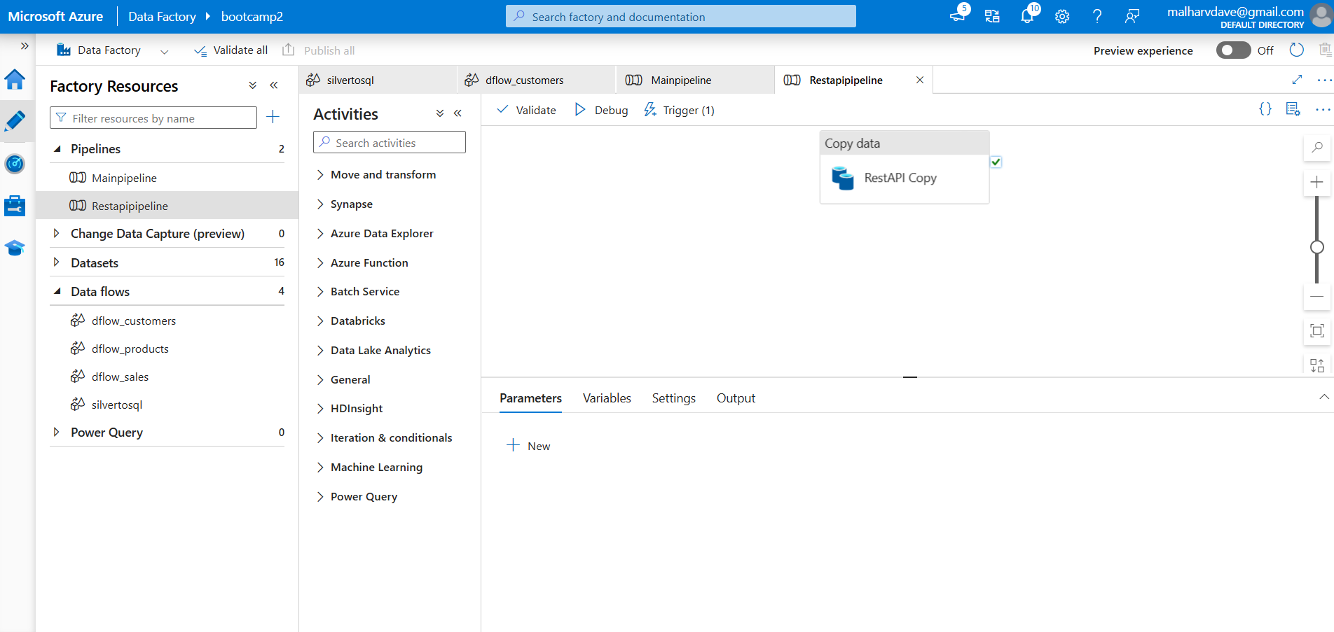

Every5mins

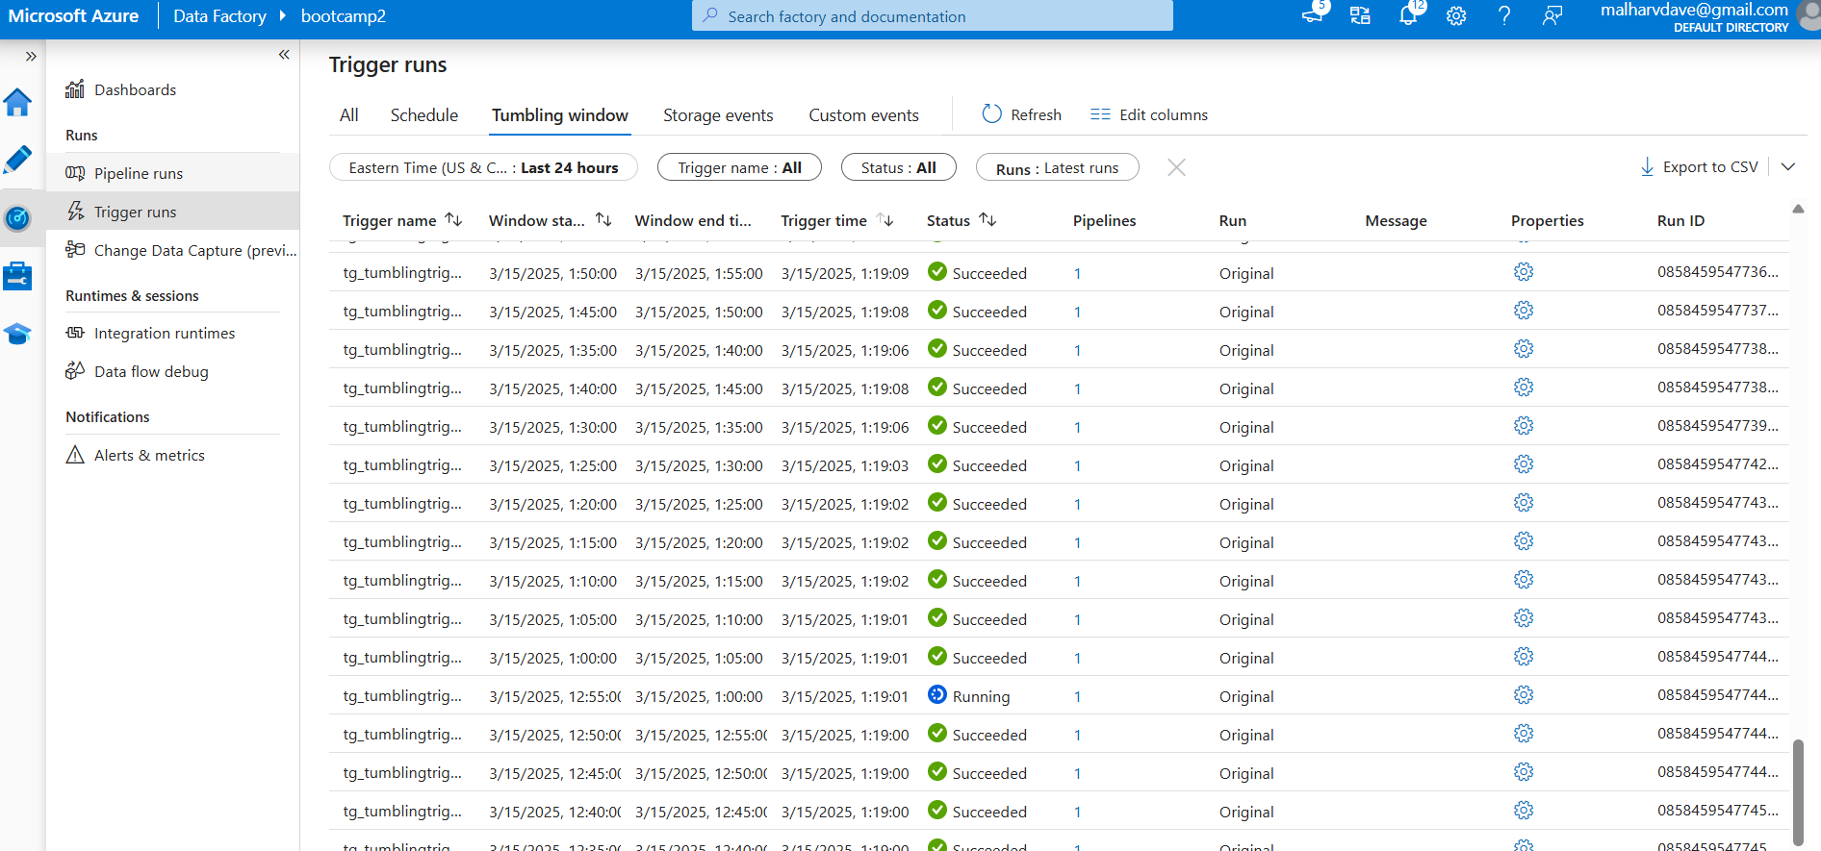

Main Pipeline with ONprem(Schedule Trigger) and Product

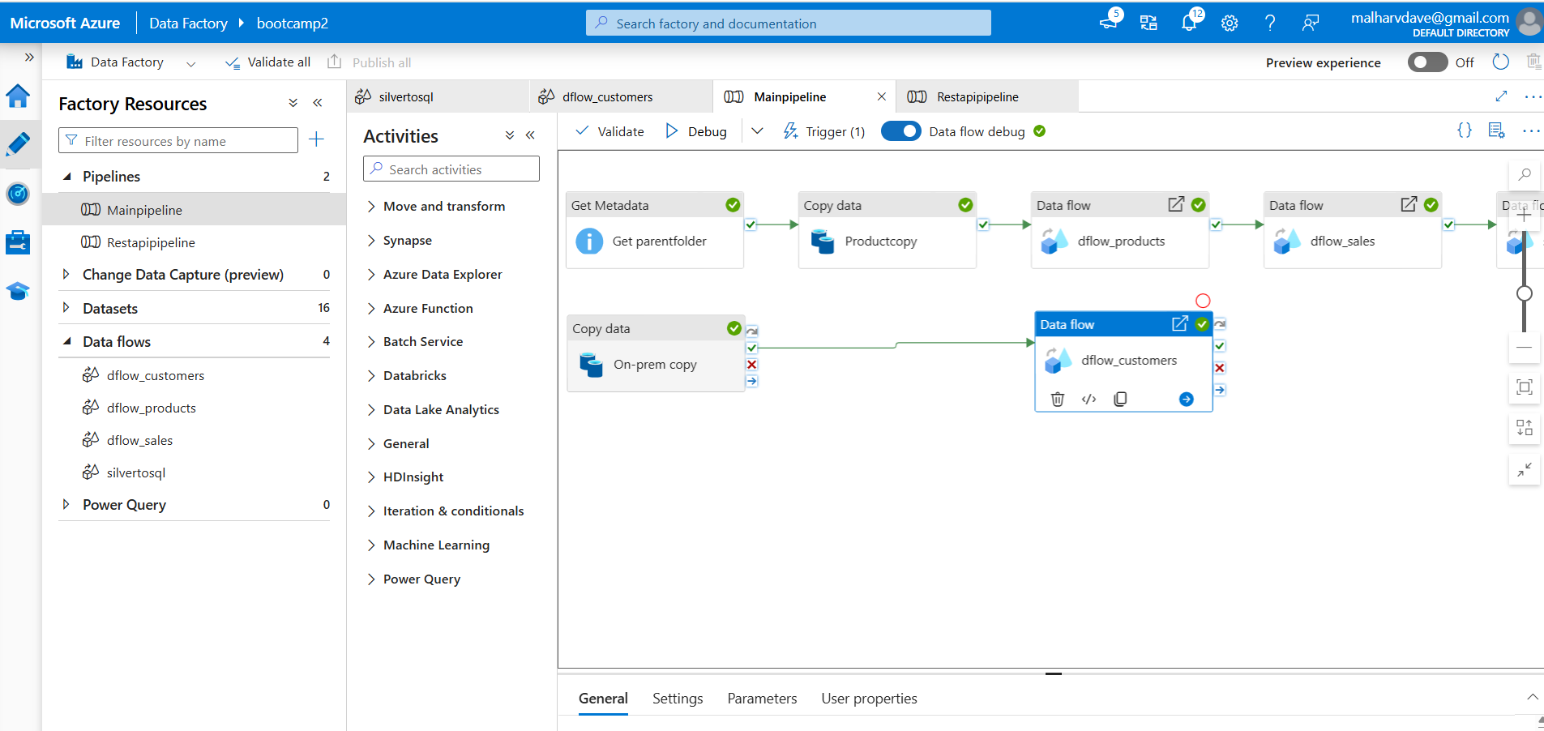

EveryHour

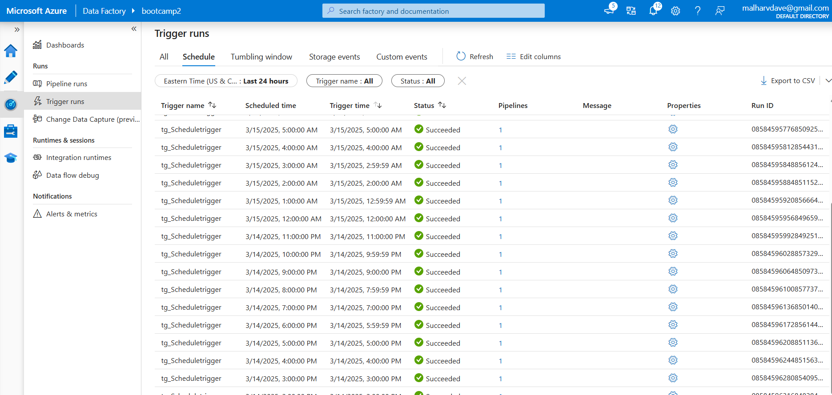

4.Created DataFlows for Bronze to Silver

First one is for Customers

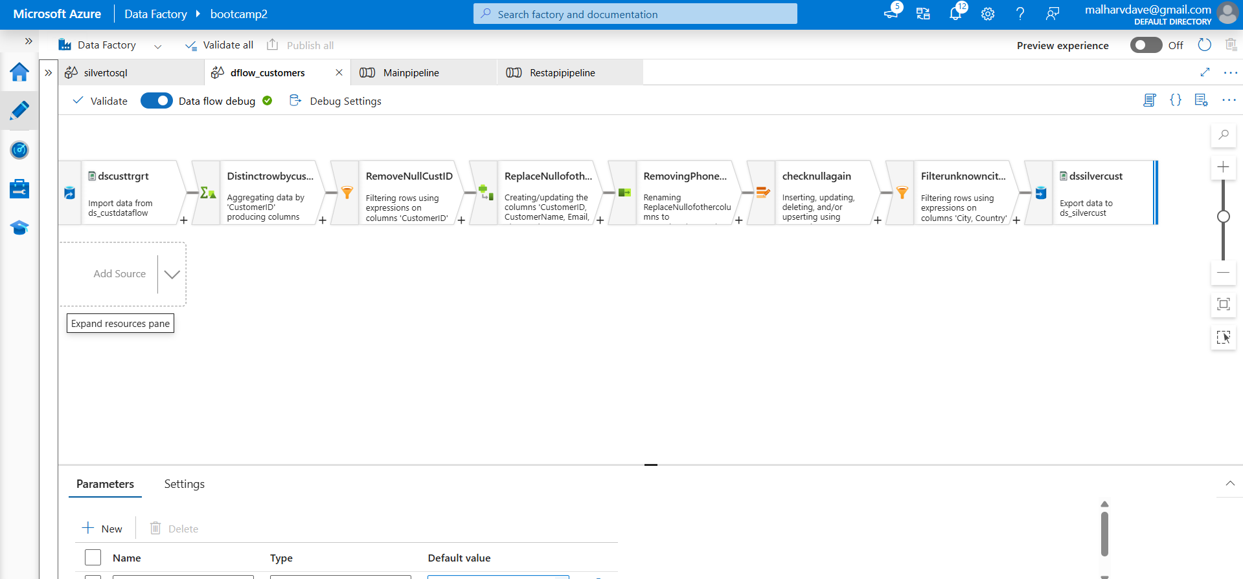

Second for Products

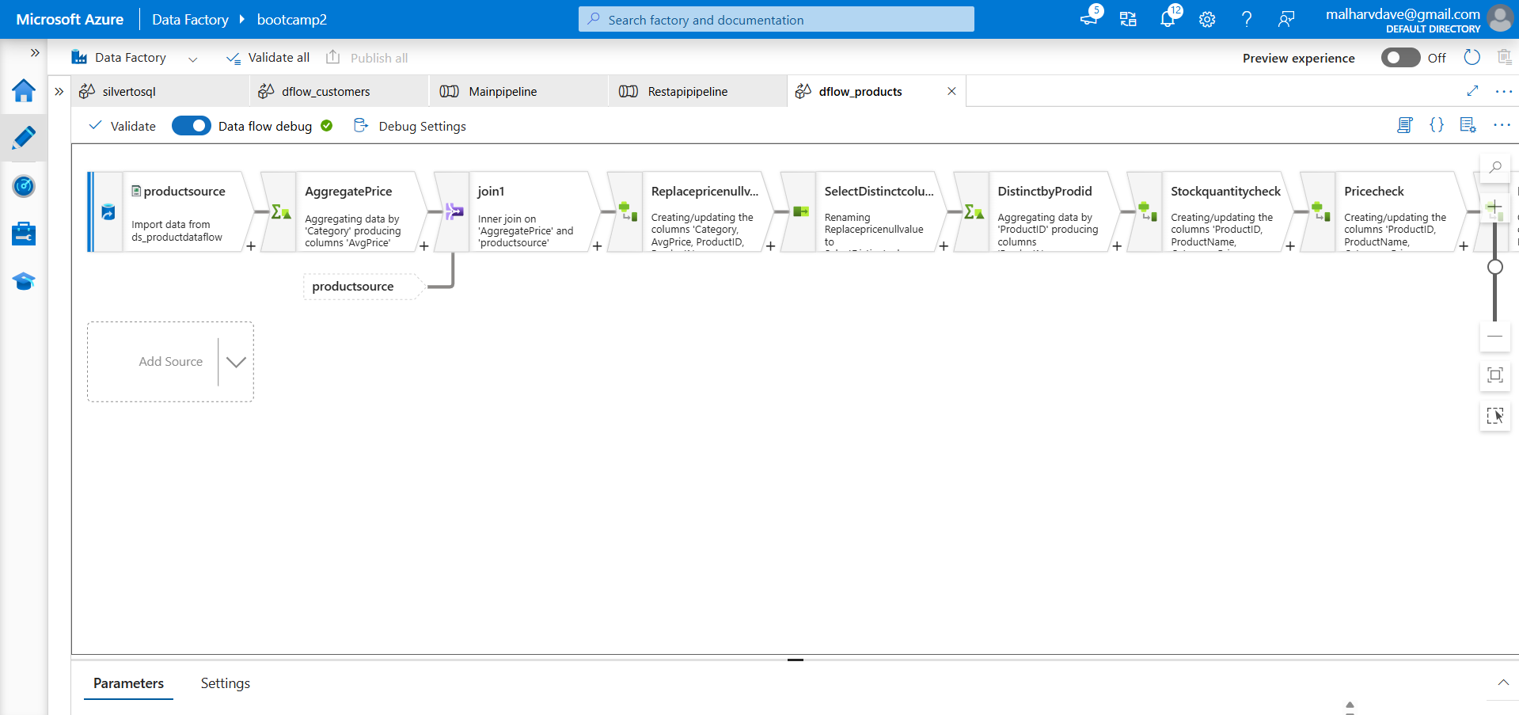

Continue Products..

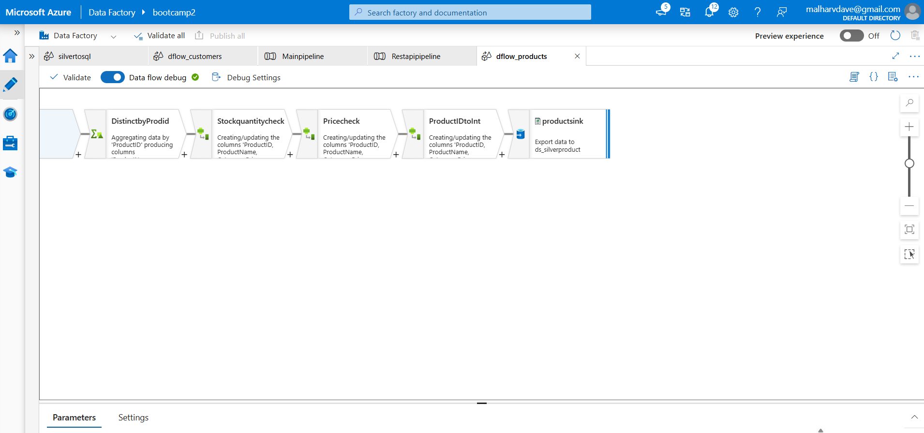

Third for Sales

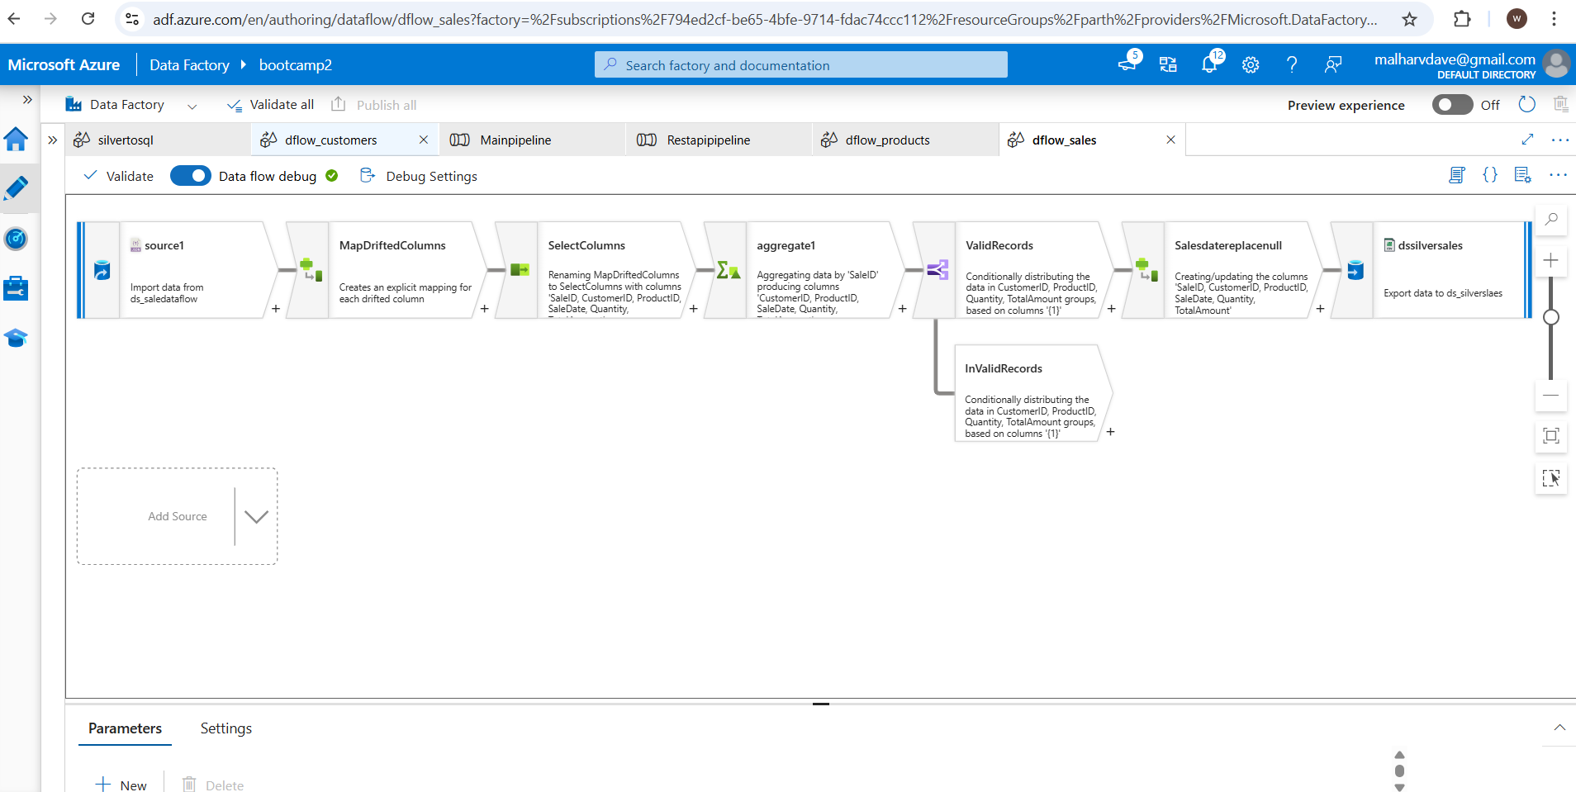

5. Created Transformation DataFlow from Silver to Target Azure SQL

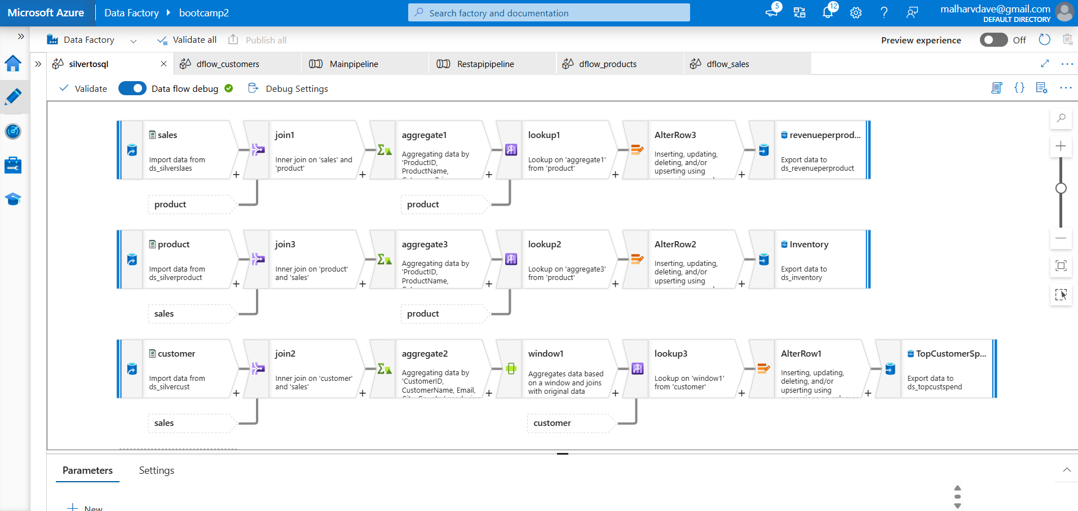

6. Pipeline Ran Successfully

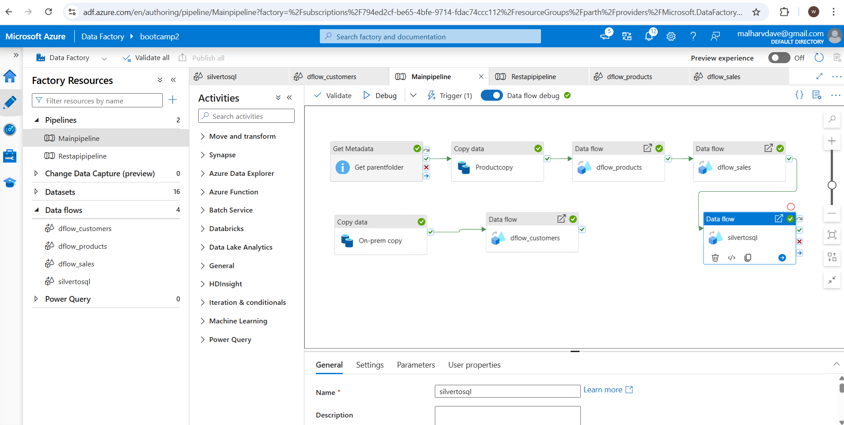

7. Data came to Bronze

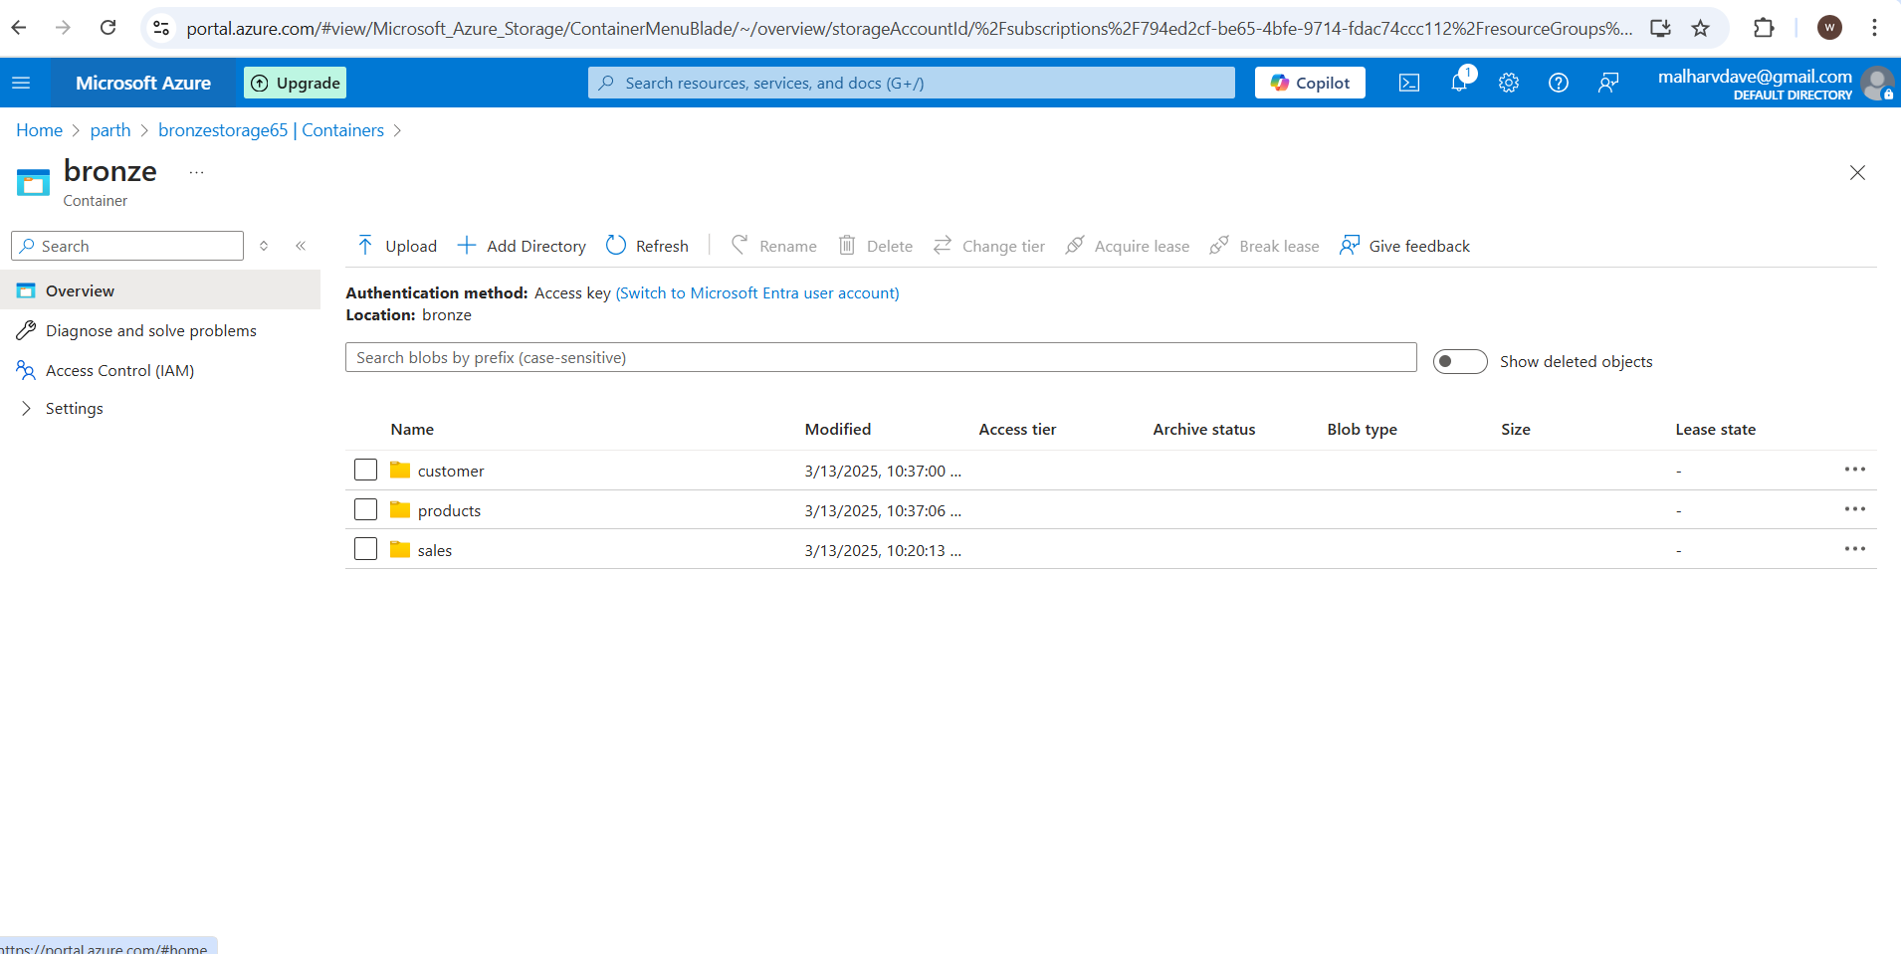

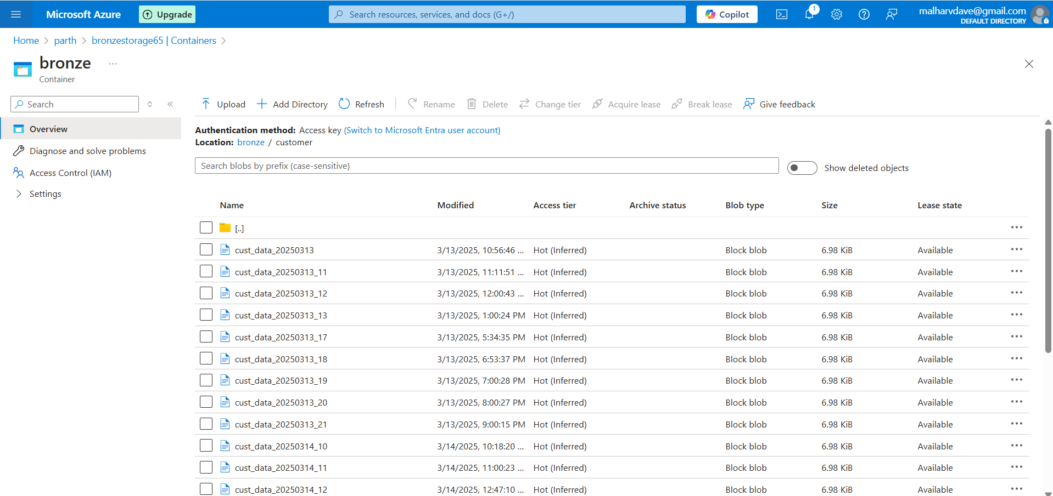

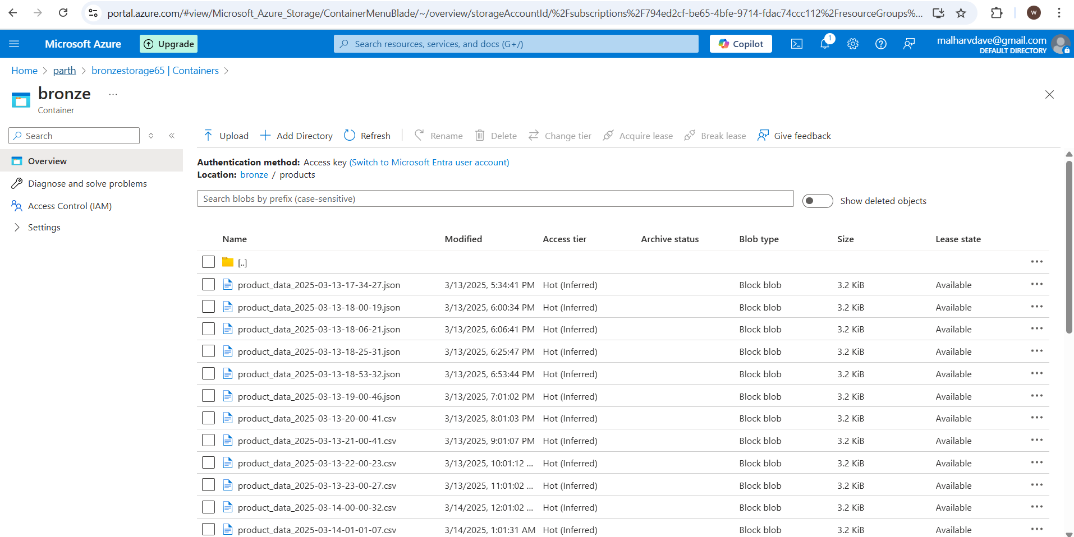

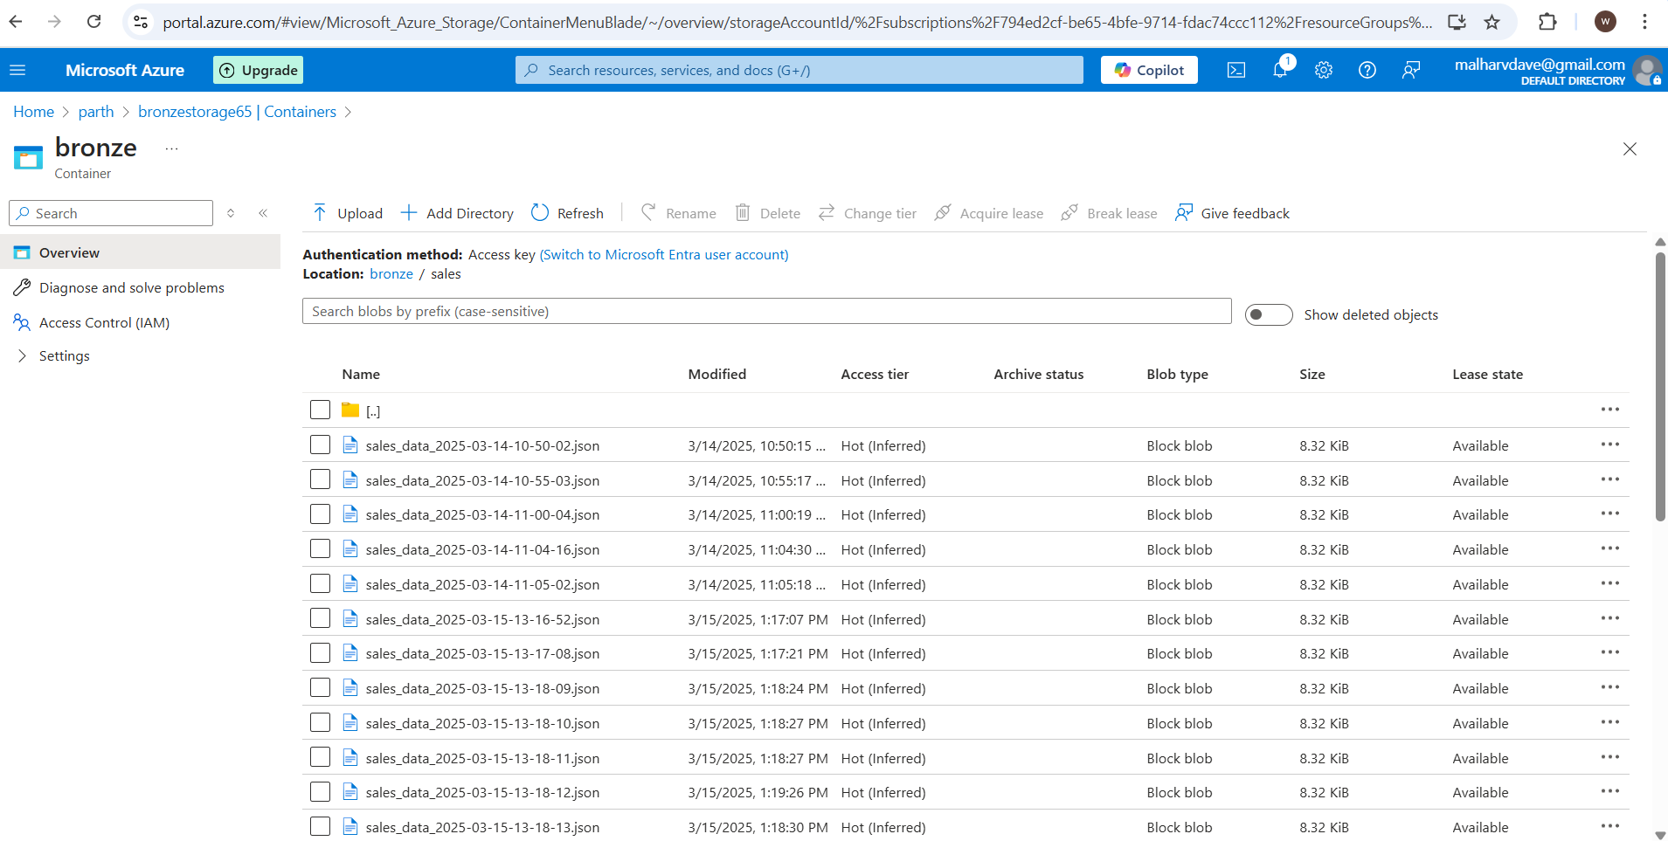

8. Data then Transfer from Bronze to Silver

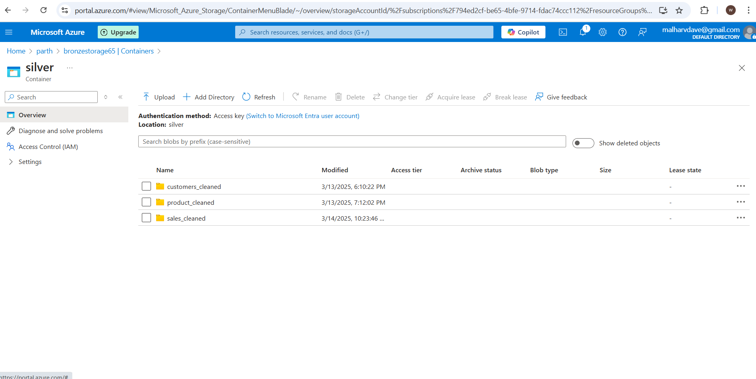

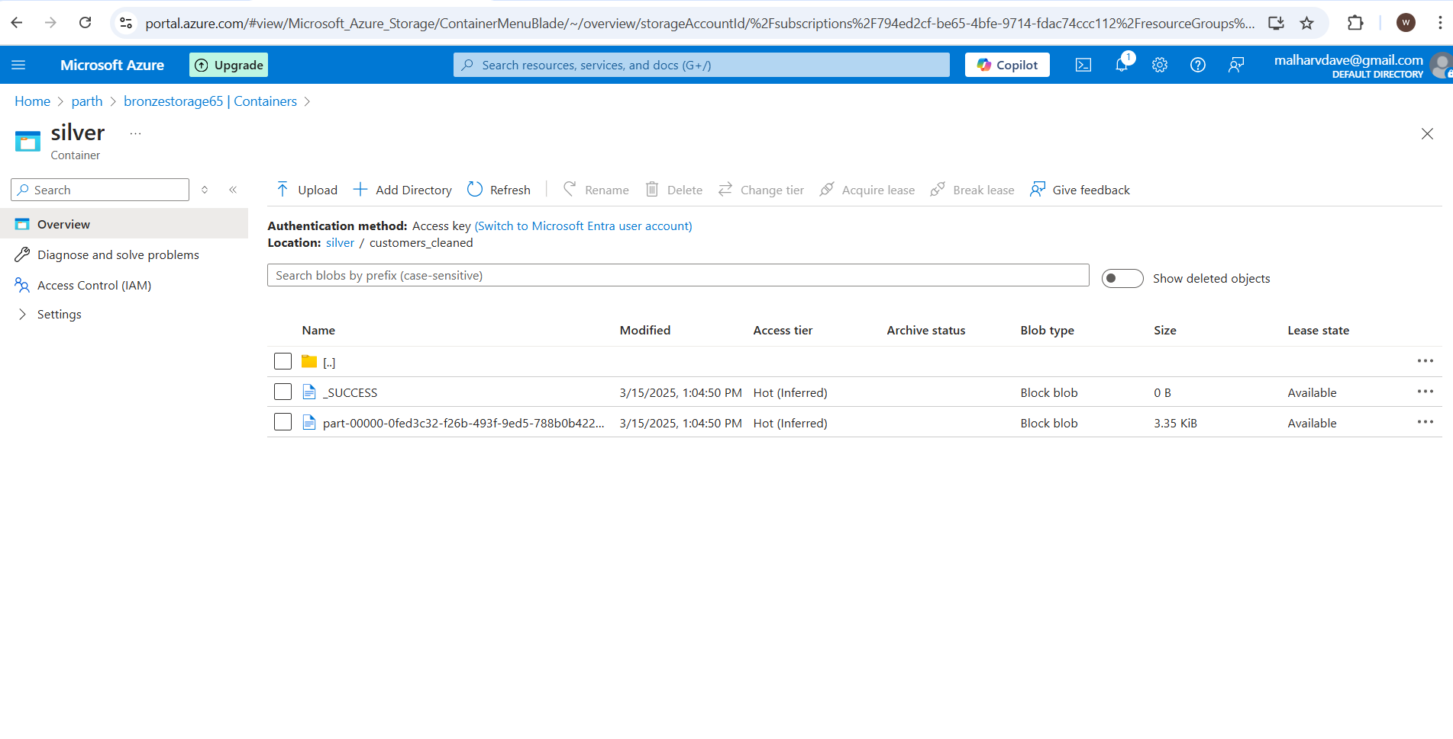

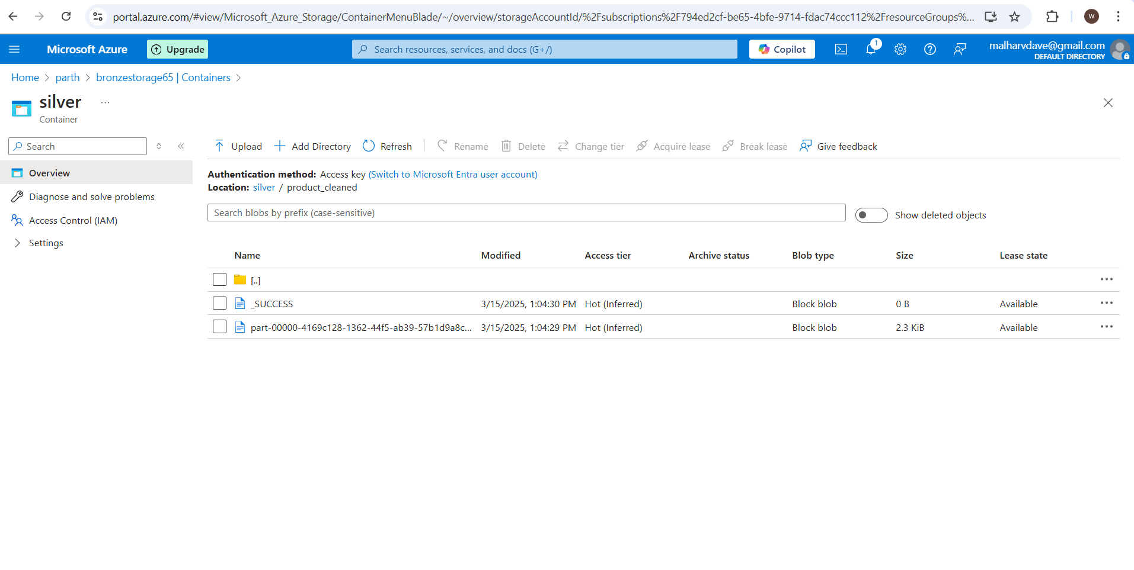

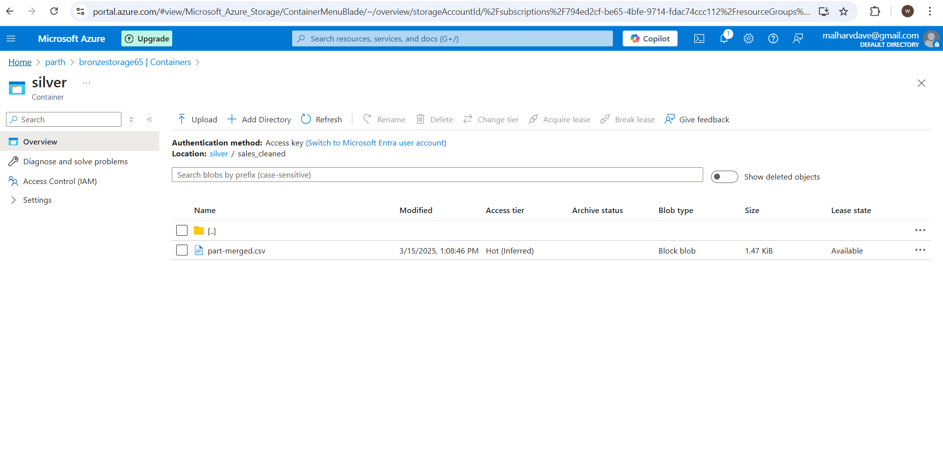

9. Target SQL database

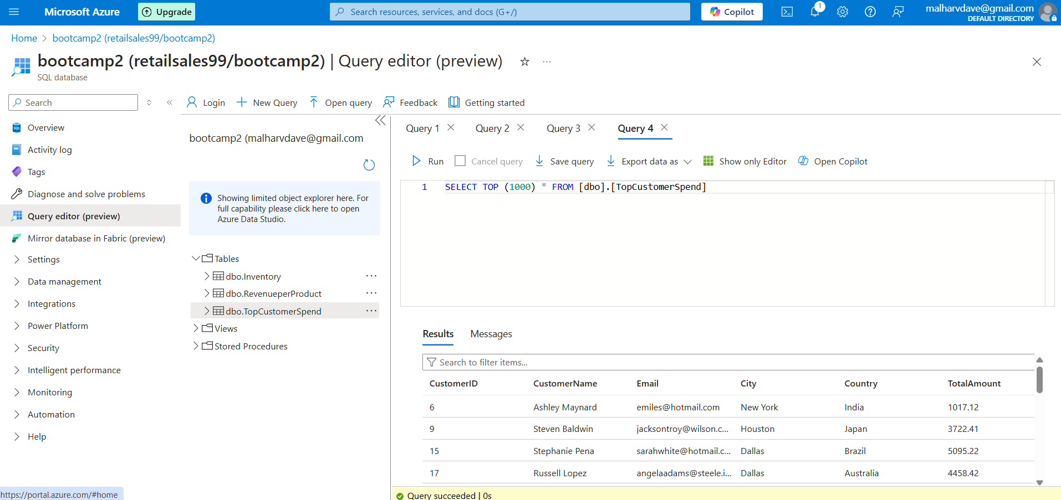

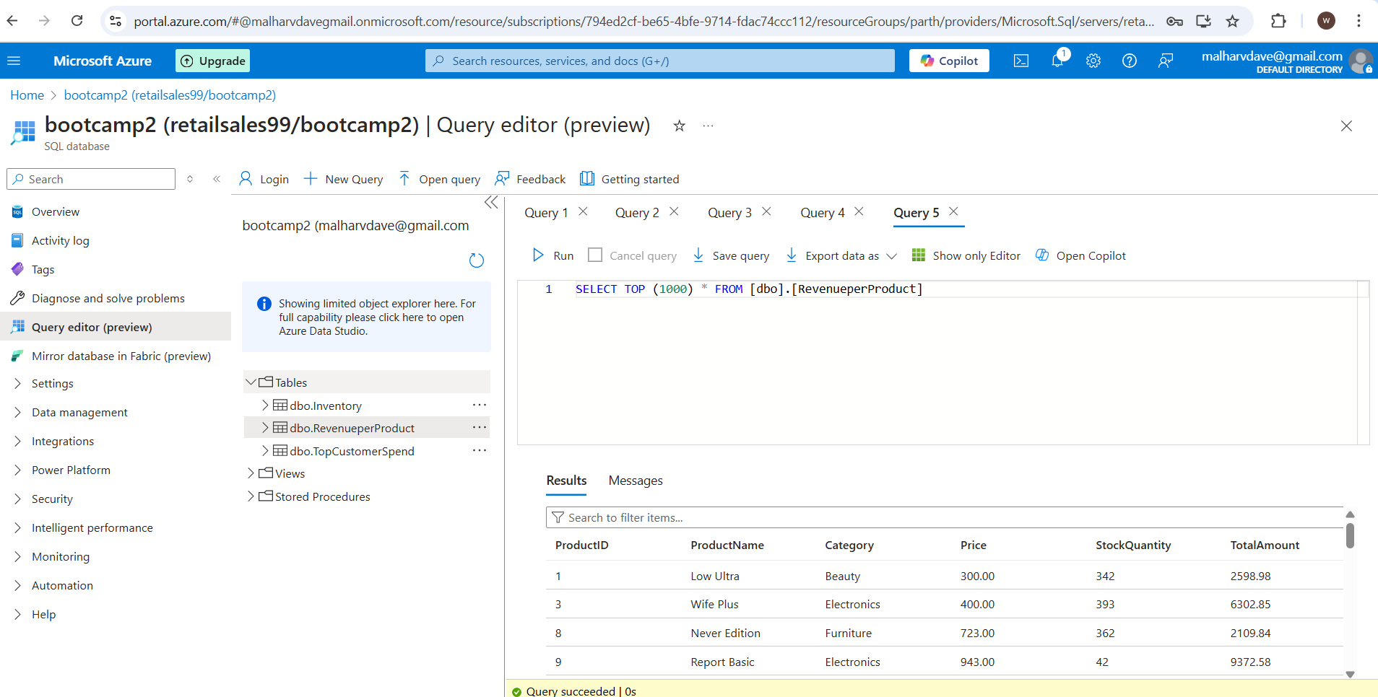

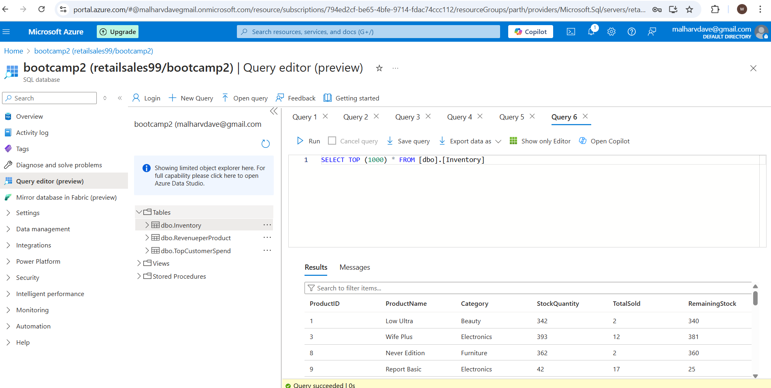

10. After successfully running the Pipeline now connected my Azure SQL database to Powerbi Desktop for Visualization

10.1 Stack Column Chart for TopCustomerSpend

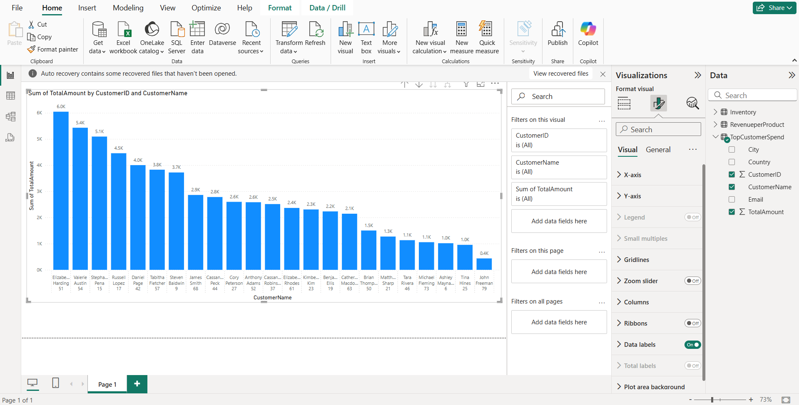

10.2 Stack Bar Chart for Revenue Per Product

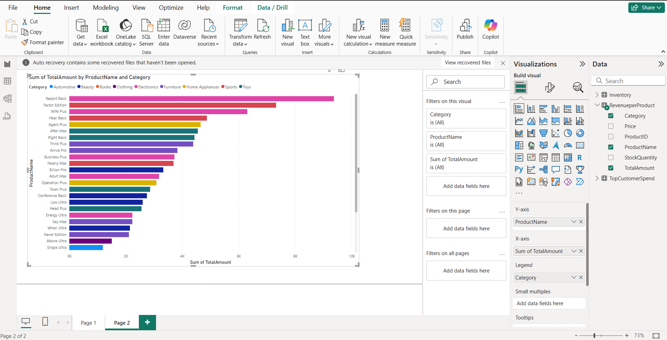

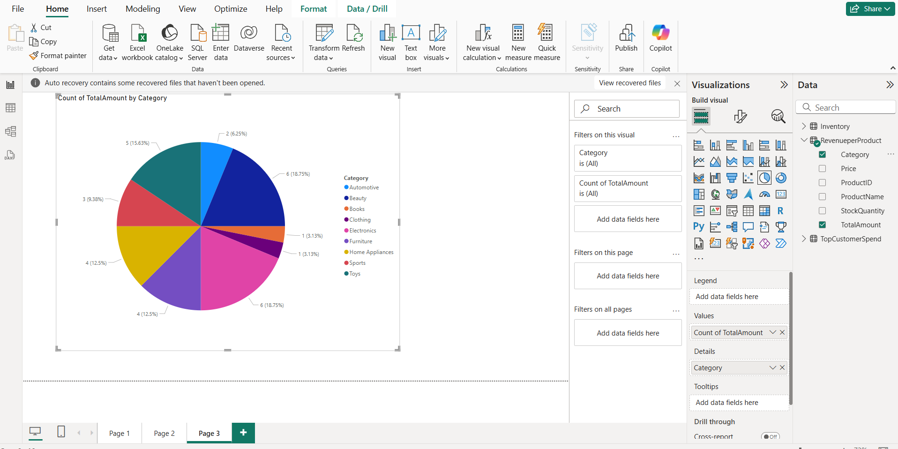

10.3 Stack bar Chart for Inventory

